**Question 1:**

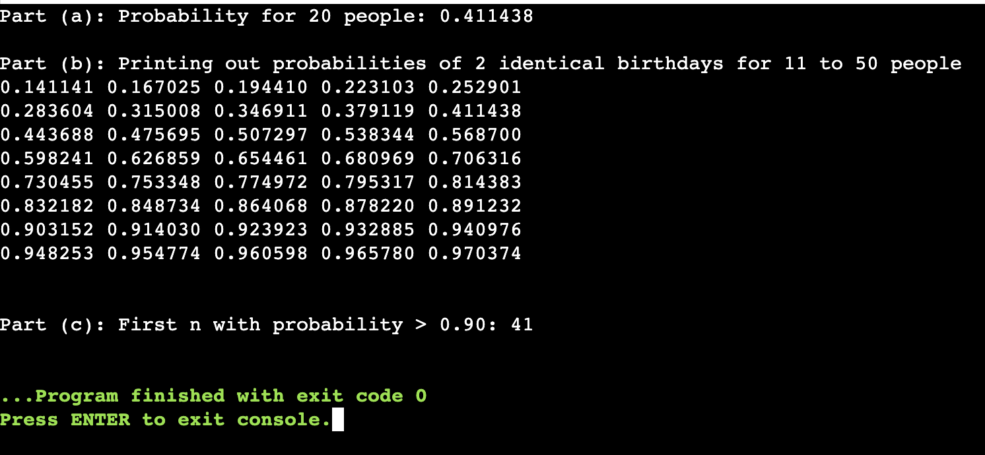

**Question 2:** 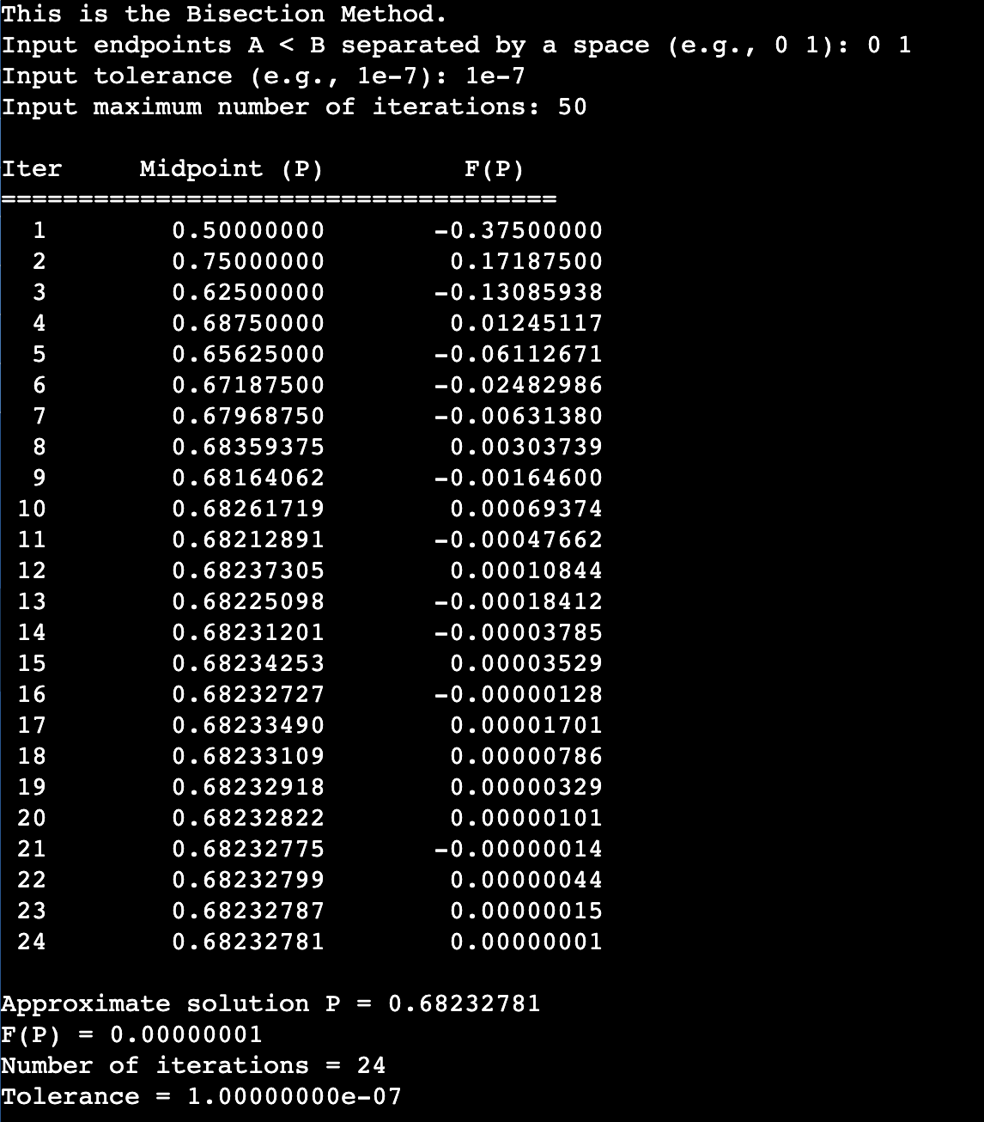

**Question 3:** 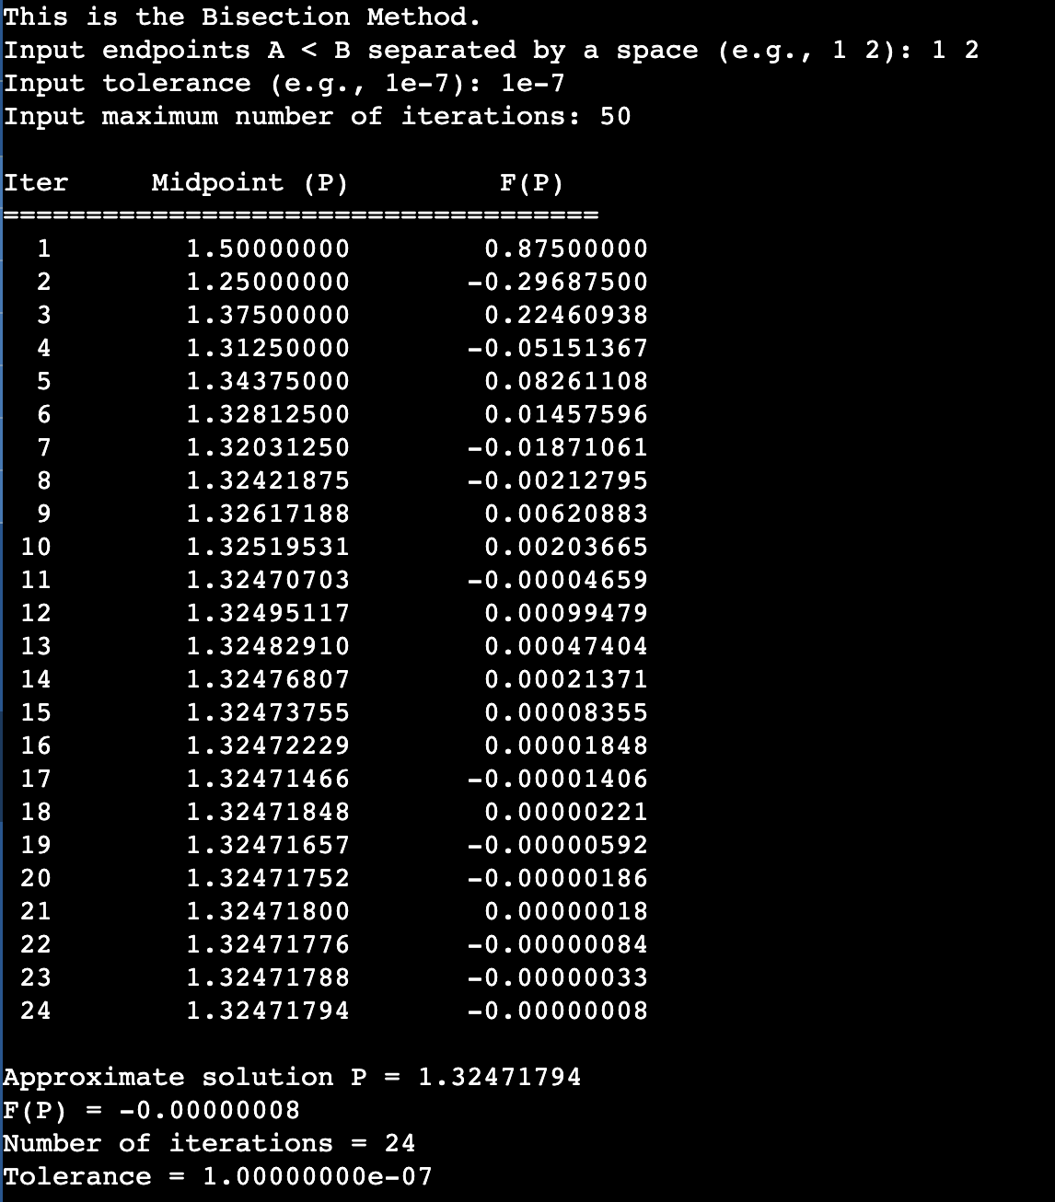

**Question 4:**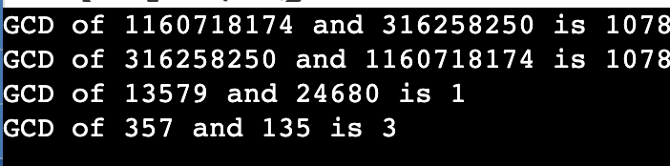

**Not same answer as book**

**Question 5:** 